[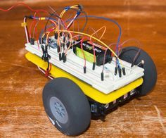](http://www.instructables.com/file/FF4EFTAIBQCG9CK/)

[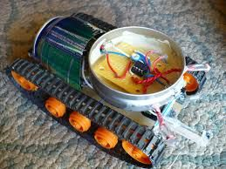](http://www.instructables.com/file/FM2WT9IIBQCG9D1/)

This is a tutorial on how to make a light following robot using Arduino, it has been simplified so that beginners can attempt this project too. This project should only take you at the most of an hour. I hope you enjoy.

**Step 1: Materials**

[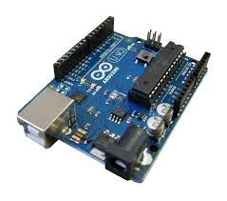](http://www.instructables.com/file/F8GTBA9IBQCG9GW/)

[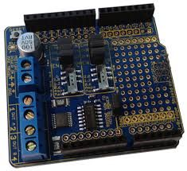](http://www.instructables.com/file/FZ6M4W4IBQCG9H4/)

[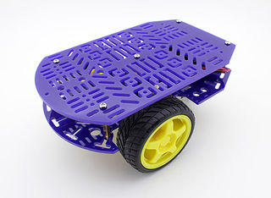](http://www.instructables.com/file/F7ZT7V8IBQCG9H1/)

[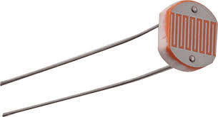](http://www.instructables.com/file/F31SEXUIBQCG9GZ/)

Arduino Uno: [http://www.freetronics.com.au/products/eleven#.VZn...](http://www.freetronics.com.au/products/eleven#.VZnKOc7MAk8)

H-Bridge shield: [http://www.freetronics.com.au/products/hbridge-dua...](http://www.freetronics.com.au/products/hbridge-dual-channel-h-bridge-motor-driver-shield#.VZnKJ87MAk8)

Chassis: [http://www.hobbyking.com/hobbyking/store/__26249__...](http://www.hobbyking.com/hobbyking/store/__26249__Kingduino_Compatible_Magician_Chassis_.html)

2X LDR/Light Dependant Resistors

2X 100k Ω Resistors

Jumper leads

3X 9v

**Step 2: Wiring**

[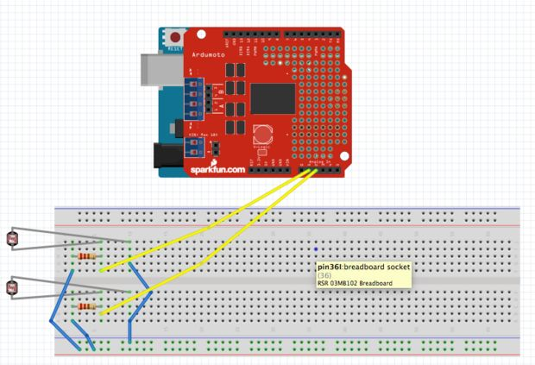](http://www.instructables.com/file/FC3673JIBQCGP1U/)

[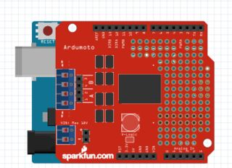](http://www.instructables.com/file/FG0JADHIBQCGP3S/)

[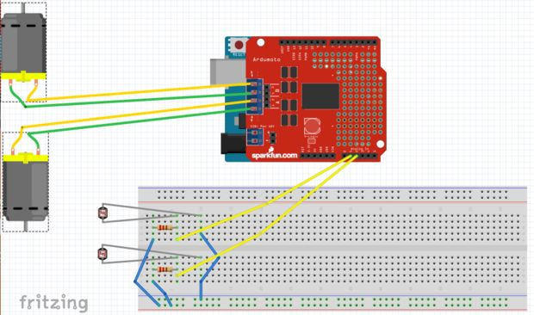](http://www.instructables.com/file/FR8C7JPIBQCGP2X/)

[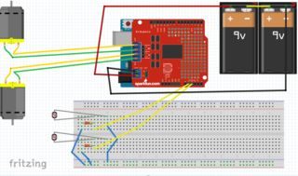](http://www.instructables.com/file/F966QLCIBQCGP0R/)

[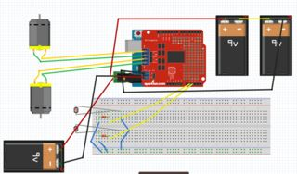](http://www.instructables.com/file/FU45QNBIBQCGOXQ/)

With the wires on the bread board that go to the side, 2 go to 5v on arduino and the other one goes to GND

It is easier to follow the pictures then me explain.

First, connect the H-Bridge shield to the Arduino Uno

Then, connect the LDR's, like in the diagram

After, insert the positive and negative of the motors in to the shield

*Now, connect 2 9v batteries in a series and then positive and negative to the spots on the shield

*Finally plug a 9v battery into the Arduino

(*Last 2 are for when you have uploaded the code)

**Step 3: Put It on the Chassis**

[](http://www.instructables.com/file/FGHVOLVIBQCGRKG/)

Put the creation on your chassis how ever you please, make it look how ever you want as well. There is much I can say about this step though.

**Step 4: Code**

Please respect that it took a while to figure out and write this code:

//Code by Jason McLaughlin

//2015

const int channel_a_enable = 6; //start motor a /left

const int channel_a_input_1 = 4; //positive/negative 1

const int channel_a_input_2 = 7; //positive/negative 2

const int channel_b_enable = 5; //start motor b /right

const int channel_b_input_3 = 3; //positive/negative 1

const int channel_b_input_4 = 2; //positive/negative 2

const int RightSensor = A1; // Read the right sensor

const int LeftSensor = A2; // Read the left sensor

// Variable definitions

int SensorLeft; // This stores the value of the Left Sensor pin to use later on in the sketch

int SensorRight; // This stores the value of the Right Sensor pin to use later on in the sketch

int SensorDifference; // This value is used to determine the difference between the Left and Right

void setup() {

pinMode( channel_a_enable, OUTPUT ); // Channel A enable

pinMode( channel_a_input_1, OUTPUT ); // Channel A input 1

pinMode( channel_a_input_2, OUTPUT ); // Channel A input 2

pinMode( channel_b_enable, OUTPUT ); // Channel B enable

pinMode( channel_b_input_3, OUTPUT ); // Channel B input 3

pinMode( channel_b_input_4, OUTPUT ); // Channel B input 4

pinMode(LeftSensor, INPUT); // Defines this pin as an input. The Arduino will read values from this pin.

pinMode(RightSensor, INPUT); // Defines this pin as an input. The Arduino will read values from this pin.

digitalWrite(A1, HIGH); // Enables LDR

digitalWrite(A2, HIGH); // Enables LDR

Serial.begin(9600); // Enables a serial connection through the Arduino to either USB or UART (pins 0&1). Note that the baud rate is set to 9600

Serial.println(" \nBeginning Light Seeking Behavior"); // Placed at the very end of void Setup() so that it is runs once, right before the void Loop() }

void loop() { SensorLeft = 1023 - analogRead(LeftSensor); // This reads the value of the sensor, then saves it to the corresponding integer.

delay(1);

SensorRight = 1023 - analogRead(RightSensor); // This reads the value of the sensor, then saves it to the corresponding integer.

delay(1);

SensorDifference = abs(SensorLeft - SensorRight); // This calculates the difference between the two sensors and then saves it to an integer.

// This section of the sketch is used to print the values of the // sensors through Serial to the computer. Useful for determining // if the sensors are working and if the code is also functioning properly.

Serial.print("Left Sensor = "); // Prints the text inside the quotes.

Serial.print(SensorLeft); // Prints the value of the Left Sensor.

Serial.print("\t"); // Prints a tab (space).

Serial.print("Right Sensor = "); // Prints the text inside the quotes.

Serial.print(SensorRight); // Prints the value of the Right Sensor.

Serial.print("\t"); // Prints a tab (space).

// This section of the sketch is what actually interperets the data and then runs the motors accordingly.

if (SensorLeft > SensorRight && SensorDifference > 75) { // This is interpreted as if the Left sensor reads more light than the Right Sensor, Do this:

analogWrite( channel_a_enable, 255);

digitalWrite( channel_a_input_1, LOW);

digitalWrite( channel_a_input_2, HIGH);

analogWrite( channel_b_enable, 255);

digitalWrite( channel_b_input_3, HIGH);

digitalWrite( channel_b_input_4, LOW);

Serial.println("Left"); // This prints Left when the robot would actually turn Left.

delay(50);

}

if (SensorLeft < SensorRight && SensorDifference > 75) { // This is interpreted as if the Left sensor reads less light than the Right Sensor, Do this:

analogWrite( channel_a_enable, 255);

digitalWrite( channel_a_input_1, HIGH);

digitalWrite( channel_a_input_2, LOW);

analogWrite( channel_b_enable, 255);

digitalWrite( channel_b_input_3, LOW);

digitalWrite( channel_b_input_4, HIGH);

Serial.println("Right"); // This prints Right when the robot would actually turn Right.

delay(50);

}

else if (SensorDifference < 75) { // This is interpreted as if the difference between the two sensors is under 125 (Experiment to suit our sensors), Do this:

analogWrite( channel_a_enable, 255);

digitalWrite( channel_a_input_1, HIGH);

digitalWrite( channel_a_input_2, LOW);

analogWrite( channel_b_enable, 255);

digitalWrite( channel_b_input_3, HIGH);

digitalWrite( channel_b_input_4, LOW);

Serial.println("Forward"); // This prints Forward when the robot would actually go forward.

delay(50);

}

Serial.print("\n");

}

Top of Form